Name Li Jiajun | 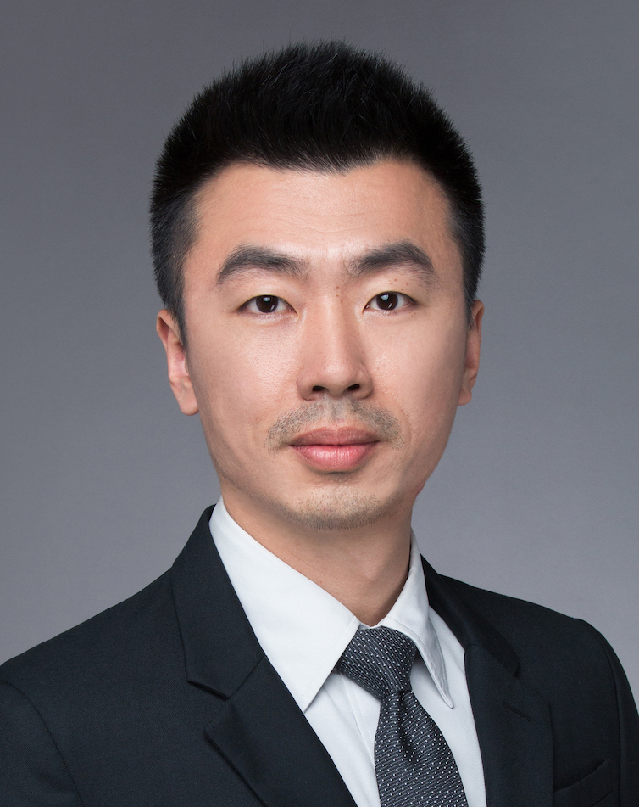
Gender Male
Birthday 1983.12
Location Shanghai
Status Married
Education background
2002.09 – 2006.07.20 Shanghai Maritime University Marine engineering
Major & degree Bachelor in Engineering

Working Experience
2016.02 – Now Planning and Logistics Department Shanghai Volkswagen Powertrain Co.,Ltd
Position Expert of demand & supply resource management (Manager Level.3)
- Lead and manage the team of resource management.
- Risk Parts Control
- Attend the regular meeting of China region’s risk resources, with the colleagues from VGC, SAIC-VW, FAW-VW PU & LO department to discuss the solutions for solving supply chain problem.
- Report the risk parts’ status to the top management team on a regular basis.
- Review and approve the “Risk Part Weekly Report” with the team, and post to the top management team.
- Make the components’ banking plan to cover the period of demand unstable. Check and make the backlog plan along with the demands fluctuating.
- In charge of the “Site Visit Team (SVT)”with Quality, Logistics, Purchasing，visit the supplier with potential risks incapacity, production, quality, delivery etc., support and solve the problems in house at their plant.
- Set long-term planning to the risk parts, nominate correspondence team member tracking , monitoring and reporting the part status.
- Set risk enquiry plan, supervise team member to release the info at EDI and check the summary report.
- Supplier Mnagement
- Arrange team member to make the Supplier KPI (VW-SRS), check the monthly report.
- Make and track the capacity planning (roughly 120 suppliers, 310 different parts involved) together with VGC and FAW-VW team,
- Support the key supplier to make the preparation of production along with powertrain strategy of VW China. Successfully launched switch from EA111 to EA211；Replaced all original MPI engines by 1.5L engine, and so on.
- Be the team member of VWPT-KTM² with cross function team from PU, QA and Project to manage the suppliers During the entire project lifetime.
- Support the suppliers with KTM²
- Mold & tooling management Module & Tolling Management
- Together with PU, allocate the molds cost (VWPT & FAW-VW), And maintain the cost information into systems.
- Manage all molds as fixed assets and check the checking report from team member.
- SRS (Supplier Rating System) online implementing project (2016)
Be the responsible person, participated the whole project to ensure the system online on time finally. Also, all the JVs of China region are using this rating system for logistics KPI.
Performance: This system optimize the level of logistics’ operation. The average KPI rating was be increased from Note 87 (Mar.2016) to Note 92 (Dec. 2016).
- Project of KTM²risk of supply chain summary（2016年）
Be the responsible person, participated the whole project.
The target of this project is to analysis the data of supplier chain risk from 2009 to 2015. Then try to find some logics in these cases for supplier management in the future.
Performance: For example: "Remark the schedule of risk enquiry plan, added some details in it. Then to decreased the risk parts finally. The quantity of 2016 risk parts was less than the average quantity from 2009 to 2015, about 25%.
2009. 07– 2016.02 Planning and Logistics department Shanghai Volkswagen powertrain Co.,Ltd
Position Officer of demand & supply resource management
- Risk part controlling
- Make and send the critical parts report
- Attend the China region risk resource regular meeting, cooperate with VGC, SAIC-VW, FAW-VW LO & BU to discuss the solutions to solve engine supplier chain problem.
Tracking the long-term risk parts for production, delivery and stock level.
- Capacity management of supplier
- Visit the supplier plant for risk parts, to find the production process problem on site. Especially for Casting and foundry supplier, I have more experience.(Below three plants are all casting supplier)
- In 2011, to support the KPSNC Loutang plant for launch. The main target is to ensure the first Aluminum Cylinder block of VW SOP on time and the capacity can cover whole demand. Currently KPSNC is the biggest casting company in China, the cylinder block is theirs first casting produce.
- Also in 2011, support GMA Tianjin plant for capacity warning. Considering the solution on 3 ways: Rechecking production process; adjustment the shifts and staff; make the short, middle, long period ramp-up plan. Finally theirs capacity was increased from 2,100pcs/day to 2,500pcs/day.
The ZKH resource was not enough in 2014, VWPT have the gap about 38tsd. I arranged a team with production management department to support Bozhong Taicang, help them for production process. Then let Bozhong to increase capacity about 10,100pcs.
- In 2009, I start the resource management in VWPT, build the platform with VGC.
- In 2010, FAW-VW start to product EA111. That means the EA111 resource management enter “Distribution age”. I’m the responsible person of VWPT to join the teamwork.
- Be the designer of “Parts order system”, In 2010 I join the project for EDI on-line. After that, VWPT phased out “the order by mail”. At the same time, the “Time schedule” was also start running. This function help to reduce the receiving staff, reduce the logistics costs. Also, the receiving process can reach the standard of VDA6.3.
- For solving the iVM resource shortage in 2014, be the behalf of VWPT logistics business trip to Germany Ilsenburg with Q. department colleague. Negotiated with ThyssenKrupp; signature of logistics agreement, to support the project accomplish.
- Sum up the experience of supplier chain management, share to VWPT internally (PU & LO), the subject is 《Capacity management》
- The project of Cam raw part localization(2015)
Support to analysis of capacity and gap
This project broken the monopoly of CKD cam in EA211 engine. Also to solve the capacity problem about cam raw part is not enough for VW China in 2015. Finally the new supplier Jiangsu Sunway started to delivery, the PPAP was successful.
Performance: The project got the award of “the key quality achievement”. 2nd class. No. 2016010043

2006. 07– 2009.06 Planning and Logistics Department Shanghai Volkswagen Powertrain Co.,Ltd
Position Local parts disposition
- Release the weekly order for suppliers
- Release the 12 weeks rolling forecast
- Track the parts delivery

Skills &Others

Language Chinese & Shanghainese : Native
English： Fluent in istening; Speaking; Reading; Writing
Certification - Process-Auditor to VDA6.3 Issuing Date：2011,10,21 Shanghai
No：CN/6.3/1011016 Issuing authority：VDA
- Internal Process Auditor Date：2006,8,13 Shanghai
Issuing authority：TÜV
PC ability MS-Office, SAP, ERP
Driving license C1

